Technical Report: Hockey Web Scraping and Pandas Data Analysis

Introduction
Web scraping provides a practical way of collecting structured information from websites when data is publicly displayed but is not immediately available as a downloadable dataset. This project demonstrates a complete introductory web-scraping and data-processing workflow using Python, Requests, BeautifulSoup, and Pandas.
The project was completed in a Jupyter Notebook titled Webscraping Test (1).ipynb, with the hockey statistics page from Scrape This Site serving as the source. The notebook retrieves page 3 of the hockey statistics table, parses the HTML structure, identifies the target table, extracts its headers and records, converts the scraped information into a Pandas DataFrame, and exports the resulting dataset to Hockey.csv.
The scraped dataset contains 25 hockey team records and 9 variables, covering team performance measures including wins, losses, win percentage, goals scored, goals conceded, and goal differential.
The purpose of this technical report is to document not only the scraping process but also the data preparation, exploratory analysis, analytical findings, visualization opportunities, and recommendations that can be derived from the resulting dataset.
Important scope note: The original notebook primarily focuses on web scraping and DataFrame construction. The statistical analysis and visualizations presented in this report extend the notebook output to demonstrate how the resulting Pandas dataset can be analyzed.

1. Story of Data

1.1 Data Source
The data was collected from the hockey section of Scrape This Site, a public sandbox designed for learning web scraping. The page describes itself as a database of NHL team statistics since 1990 and specifically provides an environment for practicing pagination, searching, and web scraping.
The notebook targeted:
https://www.scrapethissite.com/pages/forms/?page_num=3
The use of page_num=3 means that the project intentionally scraped page 3 rather than crawling the entire website. The page itself contains 25 items and includes pagination controls for additional pages.

1.2 Data Collection Process
The collection process followed these stages:
- Import the required Python libraries.
- Define the target URL.
- Send an HTTP request using requests.get().
- Retrieve the HTML response.
- Parse the HTML using BeautifulSoup.
- Locate the hockey table.
- Extract the table headers.
- Extract each table row.
- Extract individual table cells.
- Clean extracted text using .strip().
- Create a Pandas DataFrame.
- Add the scraped records.
- Inspect the completed DataFrame.
- Export the DataFrame to CSV.
The notebook explicitly implements this sequence.

Core Scraping Code
from bs4 import BeautifulSoup
import requests
import pandas as pd

url = 'https://www.scrapethissite.com/pages/forms/?page_num=3'

page = requests.get(url)

soup = BeautifulSoup(page.text, 'html')
The process demonstrates the division of responsibilities between the libraries:
Tool | Responsibility
Requests | Retrieves the web page
BeautifulSoup | Parses the HTML
Python lists | Temporarily hold headers and rows
Pandas | Structures the data into a DataFrame
CSV | Stores the resulting dataset

1.3 Data Structure
The extracted dataset contains nine columns:
Column | Description
Team Name | Name of the hockey team
Year | Season/year represented
Wins | Number of games won
Losses | Number of games lost
OT Losses | Overtime losses
Win % | Winning percentage
Goals For (GF) | Goals scored
Goals Against (GA) | Goals conceded
+ / - | Goal differential
The exported CSV confirms 25 records and 9 fields.

1.4 Data Characteristics
The dataset contains records from 1992 and 1993. The first group includes teams such as Pittsburgh Penguins, Montreal Canadiens, Toronto Maple Leafs, Vancouver Canucks, and others, while the 1993 records include teams such as Boston Bruins, Buffalo Sabres, Calgary Flames, Detroit Red Wings, and Edmonton Oilers.
The dataset contains both:
- Categorical data: Team Name
- Temporal data: Year
- Discrete numerical data: Wins, Losses, Goals For, Goals Against
- Continuous numerical data: Win %
- Signed numerical data: + / -
One notable data-quality characteristic is that OT Losses is blank for all 25 records.

2. Data Splitting and Preprocessing

2.1 HTML Structure
Before the data could become a Pandas DataFrame, the HTML structure had to be understood.
The source page uses:
<table>
<tr>
<th>Team Name</th>
<th>Year</th>
...
</tr>

<tr>
<td>Los Angeles Kings</td>
<td>1992</td>
...
</tr>
</table>
The notebook identifies the <table> element and then works down through:
- <tr> — table rows
- <th> — table headers
- <td> — table data cells
This structural approach allows the scraper to extract only the relevant hockey information instead of collecting all text from the webpage.

2.2 Header Extraction
The notebook extracts the headers using:
hockey_team = table.find_all('th')

hockey_team_table = [
team.text.strip()
for team in hockey_team
]
This produces the nine column names used to establish the DataFrame structure.
The process is important because the headers provide the schema that defines how each subsequent scraped value should be interpreted.

2.3 Row Extraction
The notebook retrieves all table rows:
column_data = table.find_all('tr')
The first row contains the headers, so the notebook skips it:
for row in column_data[1:]:
Each remaining row represents one hockey team record.

2.4 Cell Extraction
For every row, the notebook extracts the individual <td> elements:
row_data = row.find_all('td')
The values are then converted into clean text:
individual_row_data = [
data.text.strip()
for data in row_data
]
This is particularly useful because HTML frequently contains indentation and line breaks around visible text.

2.5 Handling Missing Values
The source table contains an empty OT Losses cell. The notebook extracts this as an empty string rather than assigning a numerical value. The exported CSV consequently contains a blank value for OT Losses across the records.
This should not automatically be converted to zero.
A blank could mean:
- missing information,
- unavailable information,
- not applicable,
- or an omitted value in the source.
Therefore, the appropriate approach is to investigate the meaning before imputing a value.

2.6 DataFrame Construction
The notebook creates an empty DataFrame using the extracted headers:
df = pd.DataFrame(columns=hockey_team_table)
Rows are subsequently inserted using:
length = len(df)

df.loc[length] = individual_row_data
This process eventually produces the 25-row DataFrame.

2.7 Exporting the Data
The final dataset is exported as:
df.to_csv("Hockey.csv", index=False)
The resulting file contains the same nine fields and 25 records represented in the final DataFrame.

3. Pre-Analysis
Pre-analysis focuses on understanding the structure and quality of the scraped dataset before drawing conclusions.

3.1 Dataset Dimensions
The dataset contains:
- 25 rows
- 9 columns
- 25 unique team records
- 2 years: 1992 and 1993
The dataset is therefore relatively small and is best suited for descriptive and exploratory analysis rather than advanced predictive modelling.

3.2 Data Types
The imported dataset contains:
Variable | Data Type
Team Name | Object/String
Year | Integer
Wins | Integer
Losses | Integer
OT Losses | Float/Missing
Win % | Float
Goals For | Integer
Goals Against | Integer
+ / - | Integer
The OT Losses field is interpreted as a missing numerical field because the CSV contains blank values.

3.3 Completeness
A completeness check reveals that:
- Team Name: complete
- Year: complete
- Wins: complete
- Losses: complete
- Win %: complete
- Goals For: complete
- Goals Against: complete
  - / -: complete
- OT Losses: 0 populated values
Thus, the primary data-quality issue is the absence of overtime-loss information.

3.4 Descriptive Statistics
The dataset produces the following high-level statistics:
Metric | Result
Average Wins | 37.68
Average Losses | 37.48
Average Win % | 44.86%
Maximum Wins | 56
Minimum Wins | 10
Maximum Win % | 66.7%
Minimum Win % | 11.9%
These values show considerable variation between teams.

3.5 Pre-Analysis Questions
The analysis was guided by questions such as:
- Which team recorded the highest number of wins?
- Which team had the highest win percentage?
- Which team had the strongest goal differential?
- Which team conceded the most goals?
- Which teams demonstrated positive goal differentials?
- How does winning performance relate to goal differential?
- How do the 1992 and 1993 records compare?
- Which teams appear to be the strongest and weakest performers in the selected sample?

4. In-Analysis

4.1 Ranking Teams by Wins
The number of wins provides a direct measure of team success.
The strongest result belongs to the Pittsburgh Penguins, who recorded:
- 56 wins
- 21 losses
- 66.7% win percentage
- +99 goal differential
This makes Pittsburgh the strongest team in the dataset based on wins.
The weakest result belongs to the Ottawa Senators, with:
- 10 wins
- 70 losses
- 11.9% win percentage
- -193 goal differential.

4.2 Win Percentage Analysis
Win percentage provides a standardized measure of success.
Pittsburgh Penguins recorded the highest win percentage at 0.667, equivalent to 66.7%.
The lowest was Ottawa Senators at 0.119, equivalent to 11.9%.
This wide range indicates significant variation in team performance.

4.3 Goals Scored
Goals For measures offensive production.
The highest Goals For figure belongs to the:
Pittsburgh Penguins — 367 goals
Other strong offensive performances include:
- Detroit Red Wings — 356
- Quebec Nordiques — 351
- Vancouver Canucks — 346
- Los Angeles Kings — 338
- New York Islanders — 335
This suggests that strong offensive output was an important characteristic of the highest-performing teams in the sample.

4.4 Goals Conceded
Goals Against provides an indication of defensive performance.
The highest value in the dataset is:
San Jose Sharks — 414 goals conceded
Ottawa Senators also conceded heavily with 395 goals.
This provides a strong contrast with teams such as Toronto Maple Leafs, which conceded only 241 goals.

4.5 Goal Differential
The + / - measure captures the difference between goals scored and goals conceded.
The strongest result is:
Pittsburgh Penguins: +99
The weakest result is:
San Jose Sharks: -196
A positive goal differential generally indicates that a team scored more goals than it conceded, while a negative differential indicates the opposite.

4.6 Positive vs Negative Goal Differential
Of the 25 records:
- 16 teams (64%) have positive goal differentials.
- 8 teams (32%) have negative goal differentials.
- 1 team (4%) has a zero differential.
This means the majority of records in the selected sample have more goals scored than conceded.

4.7 Relationship Between Wins and Goal Differential
The dataset suggests a clear relationship between overall team success and goal differential.
Teams with strong winning records tend to have positive differentials.
For example:
Team | Wins | Win % | + / -
Pittsburgh Penguins | 56 | 66.7% | +99
Quebec Nordiques | 47 | 56.0% | +51
Vancouver Canucks | 46 | 54.8% | +68
Detroit Red Wings | 46 | 54.8% | +81
Toronto Maple Leafs | 44 | 52.4% | +47
Conversely, the weakest teams generally show large negative differentials.
This makes goal differential a useful complementary performance indicator alongside wins and win percentage.

5. Post-Analysis and Insights

5.1 Insight 1: Pittsburgh Penguins Were the Strongest Record
Pittsburgh is the standout team in the dataset.
The team recorded the:
- Highest wins
- Highest win percentage
- Highest Goals For
- Highest goal differential
This consistency across multiple indicators strengthens the conclusion that Pittsburgh was the strongest performer within this scraped sample.

5.2 Insight 2: Ottawa and San Jose Show Severe Underperformance
The Ottawa Senators and San Jose Sharks demonstrate the weakest performance patterns.
Ottawa recorded only 10 wins and a -193 goal differential, while San Jose recorded 11 wins and a -196 differential.
Both teams combined poor win records with substantial negative goal differentials.

5.3 Insight 3: Goal Differential Reinforces Win Performance
The strongest teams generally have positive goal differentials.
This suggests that successful teams were not simply winning narrowly; many were also creating a substantial difference between goals scored and conceded.
Pittsburgh's +99 differential is particularly notable.

5.4 Insight 4: Offensive Strength Is Visible Among Top Teams
The highest-performing team, Pittsburgh, also recorded the highest Goals For figure at 367.
Detroit recorded 356, Quebec 351, and Vancouver 346.
This indicates that offensive production is an important dimension of the performance story.
However, the analysis should not claim that scoring alone causes winning because this dataset is observational and relatively small.

5.5 Insight 5: Defensive Performance Matters
San Jose conceded 414 goals, the highest figure in the dataset, while Ottawa conceded 395.
These figures help explain why both teams recorded extremely negative goal differentials.
This suggests that defensive weakness can be evaluated alongside offensive production when assessing team performance.

5.6 Insight 6: Data Quality Needs Attention
Although the scraping process successfully produced a structured dataset, the OT Losses column is completely blank.
This demonstrates an important distinction:
A technically successful scraping process does not automatically produce a completely analysis-ready dataset.
The extraction was successful, but the analyst still needs to investigate field completeness and meaning.

6. Data Visualizations & Charts
The dataset can support several useful visualizations.

6.1 Wins by Team — Horizontal Bar Chart
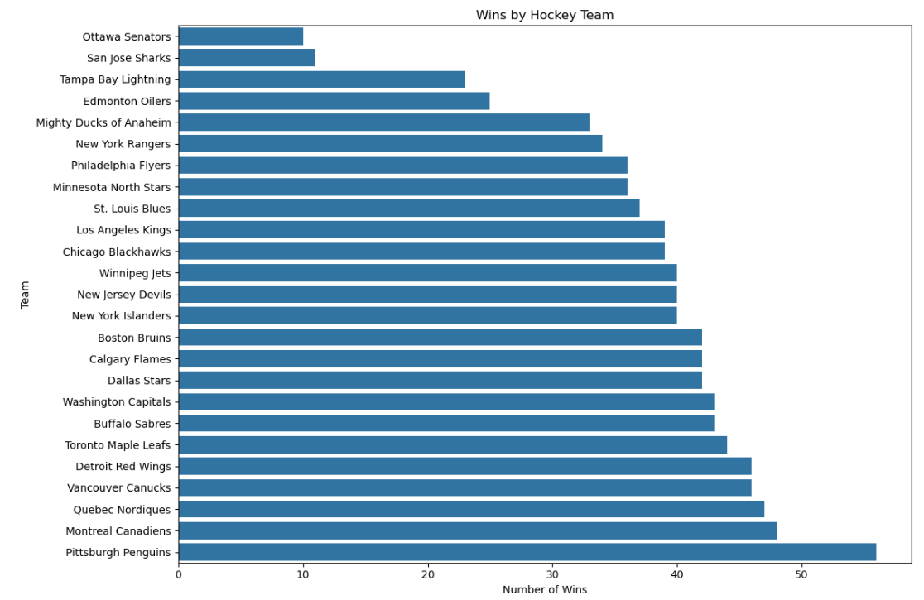
Recommended chart: Horizontal bar chart.
X-axis: Wins
Y-axis: Team Name
This visualization would immediately identify the highest- and lowest-performing teams.
Pittsburgh Penguins would appear at the top with 56 wins, while Ottawa Senators would appear at the bottom with 10 wins.

6.2 Win Percentage by Team
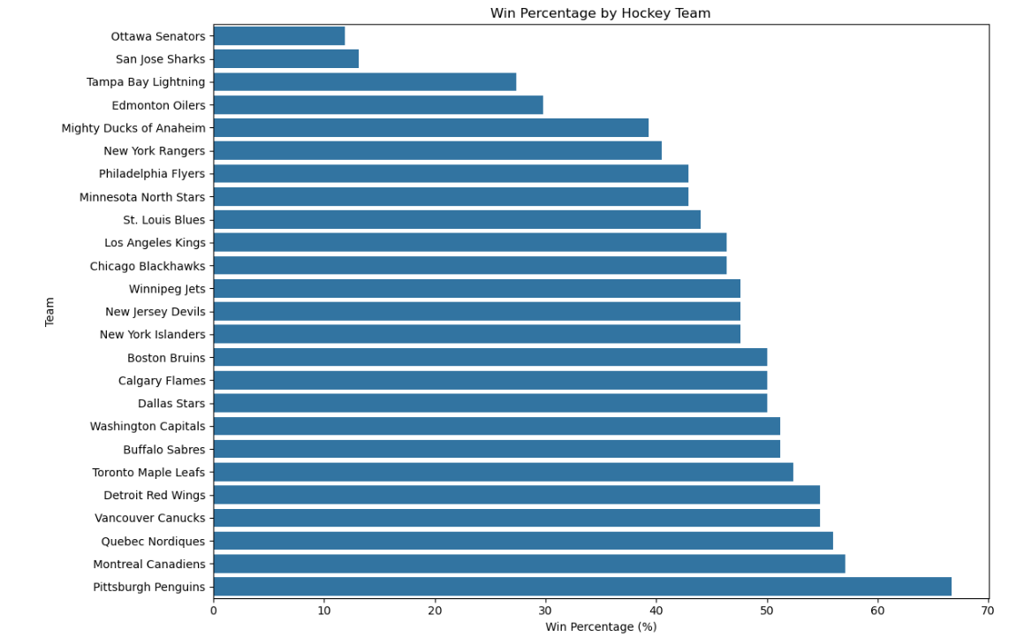
A second horizontal bar chart should rank teams according to Win %.
This would provide a more standardized comparison than raw wins.
Recommended title:
"Hockey Team Performance by Win Percentage"

6.3 Goals For vs Goals Against
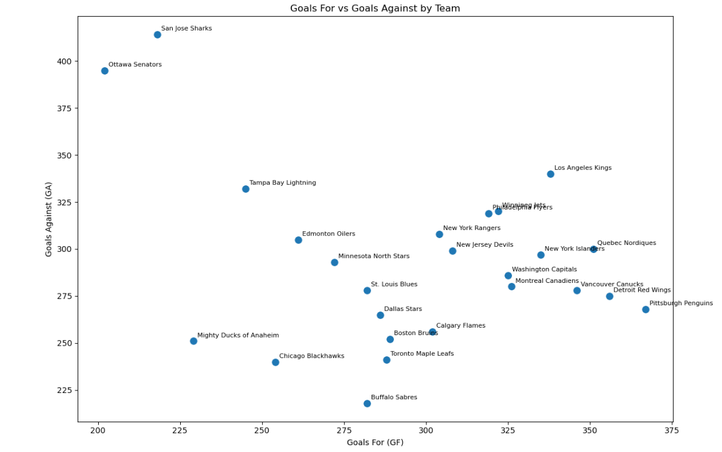
A scattered chart can compare:
- Goals For
- Goals Against
for each team.
This allows the viewer to visually identify teams that:
- scored more than they conceded,
- conceded more than they scored,
- or maintained relatively balanced scoring.

6.4 Goal Differential Chart
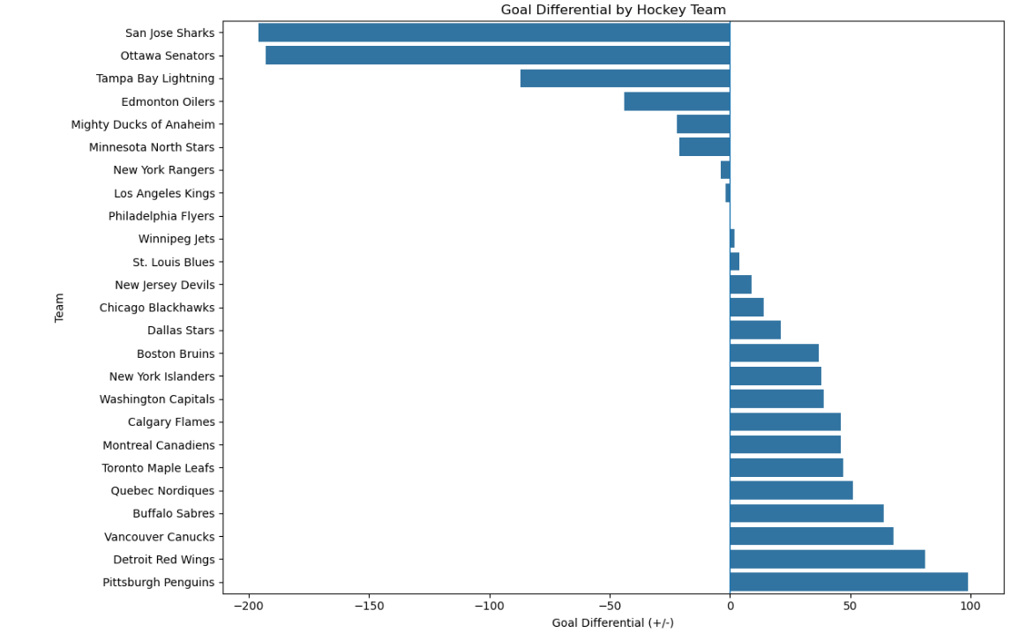
A diverging bar chart would be particularly useful.
Teams with positive values would appear on one side, while teams with negative values would appear on the opposite side.
This would make the performance gap between Pittsburgh (+99) and San Jose (-196) immediately visible.

6.5 Wins vs Losses Differential Bar Plot
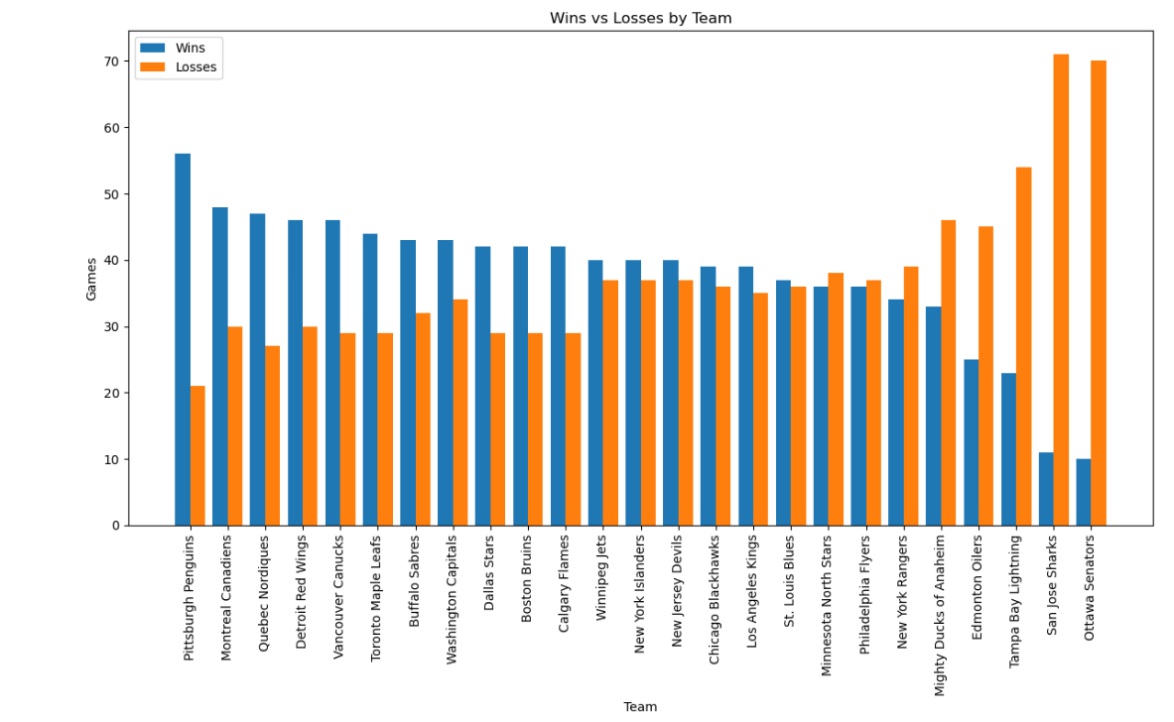
A scatter plot can investigate the relationship between:
X-axis: Wins
Y-axis: + / -
Each point represents one team.
This visualization can help determine whether teams with more wins also tend to have stronger goal differentials.

6.6 Correlation Heatmap
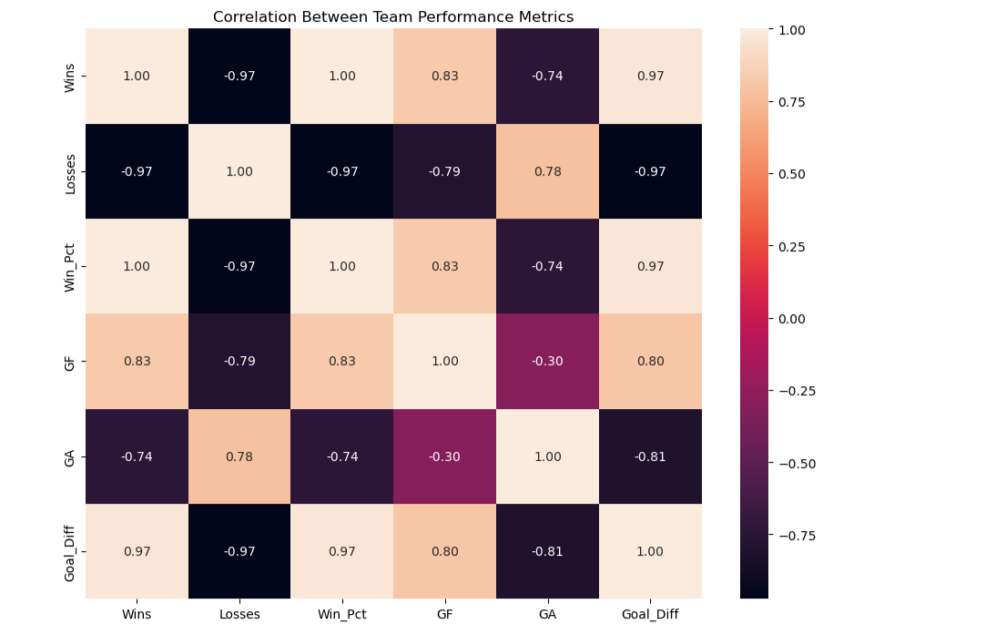

6.7 Average Goals by Year
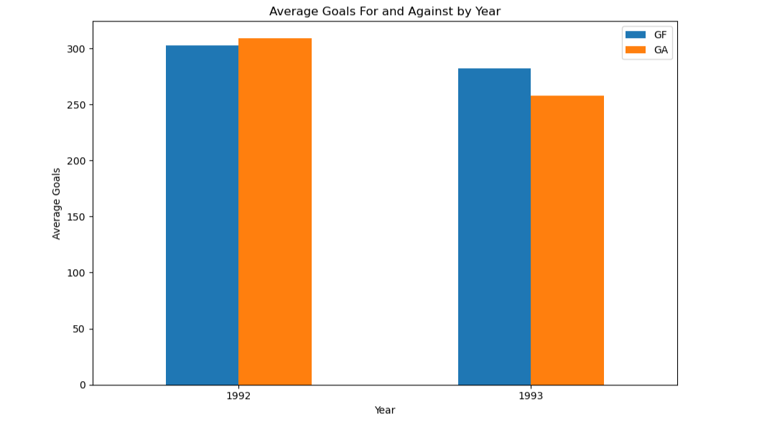

6.8 Suggested Visualization Dashboard
A simple analytical dashboard could contain:

KPI Cards
- Total Teams: 25
- Average Wins: 37.68
- Average Win %: 44.86%
- Highest Wins: 56
- Highest Goal Differential: +99

Charts
- Wins by Team
- Win % by Team
- Goals For vs Goals Against
- Goal Differential
- Wins vs Goal Differential

Data Quality Indicator
OT Losses populated: 0/25
This would communicate both analytical findings and data limitations.

7. Recommendations and Observations

7.1 Recommendation 1: Validate Scraped Data Before Analysis
A scraping pipeline should include automated checks for:
- HTTP status codes
- Expected table existence
- Expected number of columns
- Expected number of rows
- Missing values
- Data types
For example:
print(df.shape)
print(df.columns)
print(df.dtypes)
print(df.isna().sum())

7.2 Recommendation 2: Investigate Missing OT Losses
The OT Losses field should be investigated before being used in further analysis.
The analyst should determine whether:
- the source does not provide the information,
- the field is not applicable to these seasons,
- the scraper failed to extract it,
- or the source HTML intentionally contains blank cells.
The original HTML confirms that the OT Losses cells are empty.

7.3 Recommendation 3: Improve Scraper Reliability
The notebook can be strengthened by introducing:
response = requests.get(url)

if response.status_code == 200:
...
else:
print("Request failed")
Additional improvements could include:
- exception handling,
- request timeouts,
- user-agent headers where appropriate,
- validation of the target table,
- automatic pagination,
- duplicate detection.

7.4 Recommendation 4: Automate Pagination
The current notebook retrieves only page 3.
The source page provides multiple pagination links, extending beyond page 3.
A more advanced scraper could loop through pages:
for page_num in range(1, 14):
url = f"https://www.scrapethissite.com/pages/forms/?page_num={page_num}"
This would allow the project to move from a single-page extraction exercise to a larger data collection pipeline.

7.5 Recommendation 5: Preserve Raw and Clean Data Separately
A robust project should maintain:
Raw data → Cleaned data → Analysis dataset
This ensures that the original extracted information remains available if cleaning decisions need to be reviewed.

7.6 Recommendation 6: Use Pandas for Post-Scraping Analysis
Once the data has been scraped, Pandas can be used to:
- filter teams,
- sort performance,
- calculate averages,
- group by year,
- identify top performers,
- calculate correlations,
- create analytical tables,
- export processed datasets.
This demonstrates why web scraping and Pandas are complementary skills rather than separate activities.

8. Conclusion
The Hockey Web Scraping project demonstrates a complete introductory workflow for transforming publicly available web information into a structured analytical dataset.
The project begins with a hockey statistics webpage and uses Requests to retrieve the HTML, BeautifulSoup to navigate the page structure, and Pandas to create and manage the resulting DataFrame. The notebook successfully extracts the table headers and 25 team records before exporting them as Hockey.csv.
The resulting dataset contains nine fields covering team identity, season, wins, losses, win percentage, goals scored, goals conceded, and goal differential.
The extended analysis identifies the Pittsburgh Penguins as the strongest team in the selected sample, with 56 wins, a 66.7% win percentage, 367 goals scored, and a +99 goal differential. At the other end, Ottawa and San Jose show particularly weak performance, with low win totals and highly negative goal differentials.
The project also highlights an important analytical lesson: data extraction is only the beginning of the data-analysis process. Once information has been scraped, it must be inspected, validated, cleaned, analyzed, and communicated effectively.
Overall, the project establishes a strong foundation for progressing from simple HTML scraping toward more advanced Python data-analysis workflows involving automated pagination, data cleaning, exploratory data analysis, visualization, and reproducible pipelines.

9. References & Appendices

9.1 References

Primary Project Files
Webscraping Test (1).ipynb — Primary notebook containing the scraping workflow, including Requests, BeautifulSoup, HTML table selection, header extraction, row extraction, DataFrame construction, and CSV export.
Hockey.csv — Exported dataset containing 25 hockey team records and 9 fields.
Pandas Study Documentation: Hockey Web Scraping Project — Supporting study documentation developed from the notebook and dataset.

Data Source
The notebook retrieves data from the hockey statistics sandbox hosted by Scrape This Site. The page identifies itself as a practice environment for scraping NHL team statistics and provides pagination and search functionality.

Appendix A: Complete Scraping Workflow
from bs4 import BeautifulSoup
import requests
import pandas as pd

# 1. Define URL
url = 'https://www.scrapethissite.com/pages/forms/?page_num=3'

# 2. Retrieve page
page = requests.get(url)

# 3. Parse HTML
soup = BeautifulSoup(page.text, 'html')

# 4. Locate table
table = soup.find('table')

# 5. Extract headers
hockey_team = table.find_all('th')
hockey_team_table = [
team.text.strip()
for team in hockey_team
]

# 6. Create DataFrame
df = pd.DataFrame(columns=hockey_team_table)

# 7. Extract rows
column_data = table.find_all('tr')

for row in column_data[1:]:
row_data = row.find_all('td')
individual_row_data = [
data.text.strip()
for data in row_data
]

length = len(df)
df.loc[length] = individual_row_data

# 8. Inspect
print(df)

# 9. Export
df.to_csv("Hockey.csv", index=False)
This workflow corresponds closely to the actual process implemented in the uploaded notebook.

Appendix B: Recommended Pandas Validation
# Dataset dimensions
df.shape

# Column names
df.columns

# First five records
df.head()

# Data types
df.dtypes

# Missing values
df.isna().sum()

# Summary statistics
df.describe()

Appendix C: Recommended Analytical Queries

Top teams by wins
df.sort_values(
"Wins",
ascending=False
)[["Team Name", "Year", "Wins"]]

Top teams by win percentage
df.sort_values(
"Win %",
ascending=False
)[["Team Name", "Year", "Win %"]]

Strongest goal differential
df.sort_values(
"+ / -",
ascending=False
)[["Team Name", "Year", "+ / -"]]

Teams with negative goal differential
df[df["+ / -"] < 0]

Average performance
df[["Wins", "Losses", "Win %",
"Goals For (GF)",
"Goals Against (GA)",
"+ / -"]].mean()

Appendix D: Key Project Findings
Finding | Result
Total records | 25
Total fields | 9
Years represented | 1992–1993
Average wins | 37.68
Average losses | 37.48
Average win percentage | 44.86%
Highest wins | Pittsburgh Penguins — 56
Highest win percentage | Pittsburgh Penguins — 66.7%
Highest Goals For | Pittsburgh Penguins — 367
Highest goal differential | Pittsburgh Penguins — +99
Lowest wins | Ottawa Senators — 10
Lowest win percentage | Ottawa Senators — 11.9%
Lowest goal differential | San Jose Sharks — -196
Highest Goals Against | San Jose Sharks — 414
OT Losses populated | 0
The underlying figures are calculated from the 25 records contained in the supplied Hockey.csv.
Overall assessment: the project successfully demonstrates the transition from unstructured web content → parsed HTML → structured Pandas DataFrame → CSV dataset → analytical insight, making it a strong practical example for documenting foundational Python web-scraping and Pandas skills.

